Coronavirus Resources
- Coping During Covid 19 - Childmind.org:
  - https://childmind.org/coping-during-covid-19-resources-for-parents/
- Resources for Families During the Coronavirus Pandemic - Commonsense Media:
  - https://www.commonsensemedia.org/resources-for-families-during-the-coronavirus-pandemic?j=7704934&sfmc_sub=170705329&l=2048712_HTML&u=143543082&mid=6409703&jb=1011&utm_source=covid19_landingpages_jim&utm_medium=email
- Book: The Yucky Bug by Julia Cook
  - https://youtu.be/ZD9KNhmOCV4
- Book: I am a Booger: Treat Me with Respect by Julia Cook
  - Teaches the importance of proper hygiene
- World Health Organization’s Helping children cope with stress during the 2019-nCoV outbreak
- A coronavirus story for Littles
  - https://660919d3-b85b-43c3-a3ad-3de6a9d37099.filesusr.com/ugd/64c685_319c5acf38d34604b537ac9fae37fc80.pdf
- How you and Your Kids Can Destress During Coronavirus - PBS.org:
  - https://www.pbs.org/parents/thrive/how-you-and-your-kids-can-de-stress-during-coronavirus
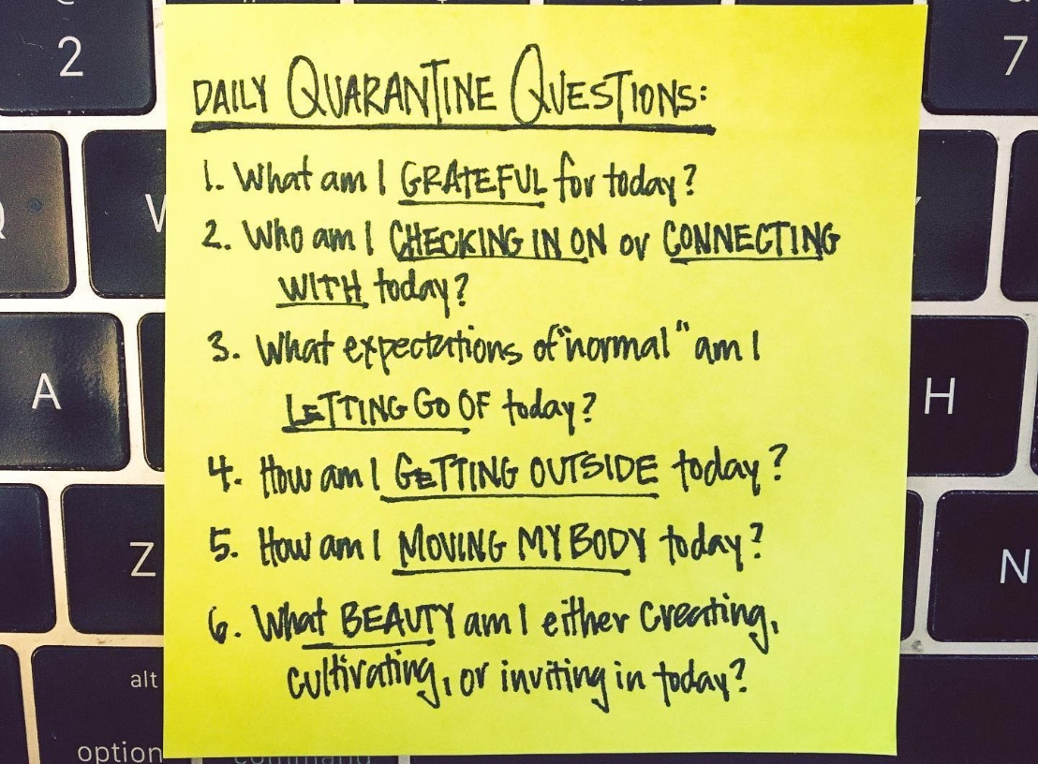
Financial Resources to Aid Families during the Corona Virus Outbreak
- Issaquah Food Bank: Coronavirus Response FAQ's
- Issaquah School District support - technology, student meals, child care info: https://issaquah.wednet.edu/news-details/2020/03/19/isd-supports-isd-offers-laptops-and-hotspots-during-school-closure-nutrition-and-meals-and-school-aged-child-care-survey
- King County’s 2-1-1 Resource Line: https://www.crisisconnections.org/king-county-2-1-1/
- Unemployment due to COVID 19: https://www.uwkc.org/news/unemployed-due-to-coronavirus-pandemic-heres-where-to-get-help/?fbclid=IwAR0gLU9w1rFDq13Wqy5XpXY80oNCCM8JVeR5Mp_86tupXmr1lcEno2oIEok
- Comcast Internet:
  - htts://corporate.comcast.com/covid-19
  - Reduced Cost Internet Program: https://www.internetessentials.com/covid19

